|  |  |
| --- | --- |
| 更新时间：2018-07-12 | cid:7f35040b-d793-464f-a78f-ba4a121884b3 |

|  |  |  |  |  |  |  |  |  |  |  |  |  |  |  |  |  |  |  |  |  |  |  |  |  |  |  |  |  |  |  |  |  |  |  |  |  |  |  |  |  |  |  |  |  |  |  |  |  |  |  |  |  |  |  |  |  |  |  |  |  |  |  |  |  |  |  |  |  |  |  |  |  |  |  |  |  |  |  |  |  |  |  |  |  |  |  |  |  |  |  |  |  |  |  |  |  |  |
| --- | --- | --- | --- | --- | --- | --- | --- | --- | --- | --- | --- | --- | --- | --- | --- | --- | --- | --- | --- | --- | --- | --- | --- | --- | --- | --- | --- | --- | --- | --- | --- | --- | --- | --- | --- | --- | --- | --- | --- | --- | --- | --- | --- | --- | --- | --- | --- | --- | --- | --- | --- | --- | --- | --- | --- | --- | --- | --- | --- | --- | --- | --- | --- | --- | --- | --- | --- | --- | --- | --- | --- | --- | --- | --- | --- | --- | --- | --- | --- | --- | --- | --- | --- | --- | --- | --- | --- | --- | --- | --- | --- | --- | --- | --- | --- | --- | --- |
| |  |  |  |  |  |  |  |  |  |  |  |  |  |  |  |  |  |  |  |  |  |  |  |  |  |  |  |  |  |  |  |  |  |  |  |  |  |  |  |  |  |  |  |  |  |  |  |  |  |  |  |  |  |  |  |  |  |  |  |  |  |  |  |  |  |  |  |  |  |  |  |  |  |  |  |  |  |  |  |  |  |  |  |  |  |  |  |  |  |  |  |  |  |  |  |  |  | | --- | --- | --- | --- | --- | --- | --- | --- | --- | --- | --- | --- | --- | --- | --- | --- | --- | --- | --- | --- | --- | --- | --- | --- | --- | --- | --- | --- | --- | --- | --- | --- | --- | --- | --- | --- | --- | --- | --- | --- | --- | --- | --- | --- | --- | --- | --- | --- | --- | --- | --- | --- | --- | --- | --- | --- | --- | --- | --- | --- | --- | --- | --- | --- | --- | --- | --- | --- | --- | --- | --- | --- | --- | --- | --- | --- | --- | --- | --- | --- | --- | --- | --- | --- | --- | --- | --- | --- | --- | --- | --- | --- | --- | --- | --- | --- | --- | | |  |  |  |  |  |  |  |  |  |  |  |  |  |  |  |  |  |  | | --- | --- | --- | --- | --- | --- | --- | --- | --- | --- | --- | --- | --- | --- | --- | --- | --- | --- | | |  | | --- | | 头像 | | |  |  |  | | --- | --- | --- | | 郑翔流程状态：     标签： | | ID:986548835 | | |  |  | | --- | --- | | cid:df75750f-a44c-4087-9d8a-b4e7eb968982 | 目前正在找工作 | | |  |  | | --- | --- | | cid:2ade7a1b-ce26-4c5f-9dfb-0aff91741a36 | 13678030675 | | |  |  | | --- | --- | | cid:542a158f-642e-4263-bdd6-cdf3723cd349 | [zhengxiang311019@163.com](mailto:zhengxiang311019@163.com) | | | cid:1edfe387-3904-44eb-852d-6c0527a9dfde男 | 27岁（1991年3月9日 ） | 现居住 深圳 | 3年工作经验 | | | |  |  |  |  |  |  |  |  |  |  |  |  |  |  |  |  |  |  |  |  |  |  | | --- | --- | --- | --- | --- | --- | --- | --- | --- | --- | --- | --- | --- | --- | --- | --- | --- | --- | --- | --- | --- | | |  |  |  |  |  |  |  |  |  |  |  |  |  |  |  |  |  |  | | --- | --- | --- | --- | --- | --- | --- | --- | --- | --- | --- | --- | --- | --- | --- | --- | --- | --- | | |  |  | | --- | --- | | **最近工作** （3年 3个月 ） | | | 职　位： | 软件工程师 | | 公　司： | 迈普通信技术股份有限公司 | | 行　业： | 无 | | |  |  | | --- | --- | | **最高学历/学位** | | | 专　业： | 通信工程 | | 学　校： | 西南民族大学 | | 学历/学位： | 本科 | | |  |  | |  |  |  |  |  |  |  |  |  |  |  |  |  |  |  |  |  |  |  |  |  |  |  |  |  |  |  |  |  |  |  |  |  |  |  |  |  |  |  |  |  |  |  |  |  |  |  |  |  |  |  |  |  |  |  |  |  |  | | --- | --- | --- | --- | --- | --- | --- | --- | --- | --- | --- | --- | --- | --- | --- | --- | --- | --- | --- | --- | --- | --- | --- | --- | --- | --- | --- | --- | --- | --- | --- | --- | --- | --- | --- | --- | --- | --- | --- | --- | --- | --- | --- | --- | --- | --- | --- | --- | --- | --- | --- | --- | --- | --- | --- | --- | --- | | |  | | --- | | **个人信息** | | |  |  |  | | --- | --- | --- | | |  |  | | --- | --- | | 户口/国籍： | 成都 | | | |  |  | | --- | --- | | 婚姻状况： | 未婚 | | | |  |  | | --- | --- | | 家庭地址： | 四川省成都市一环路南四段西南民族大学武侯校区 (邮编：610041) | | |  | |  | |  |  | | --- | | **求职意向** | | |  |  |  |  |  |  | | --- | --- | --- | --- | --- | --- | | |  |  | | --- | --- | | 期望薪资： | 15000-19999元/月 | | |  |  | | --- | --- | | 地点： | 深圳 | | | |  |  | | --- | --- | | 职能/职位： | 软件工程师   嵌入式软件工程师 | | |  |  | | --- | --- | | 行业： | 通信/电信/网络设备 计算机软件 | | | |  |  | | --- | --- | | 到岗时间： | 1周内 | | |  |  | | --- | --- | | 工作类型： | 全职 | | |  |  | |  |  | | --- | | **工作经验** | | |  |  |  |  |  |  |  |  |  |  |  | | --- | --- | --- | --- | --- | --- | --- | --- | --- | --- | --- | | |  |  | | --- | --- | | 2015/7-至今 | 迈普通信技术股份有限公司 (3年 3个月 ) | |  | 1000-5000人 | |  | **软件工程师** | | |  |  | | --- | --- | | 工作描述： | 1、基于Linux和VxWorks系统，在公司提供的系统平台下，基于编码规范高质量完成C编程任务；  2、熟悉上层协议的开发流程，能够独立进行模块详细设计，编码，调试，集成测试；  3、熟悉交换机的框架结构，熟悉BCM芯片和CTC芯片的二层转发流程，熟悉生成树协议、环回检测协议等多种二层环路检测协议； 4、熟悉路由器的控制框架和快速转发平面架构，熟悉ipsec安全协议；  工作绩效属于中上等，能够按时保证质量的完成上级安排给我的任务，得到了公司领导的认可。 | | | | |  |  | | --- | | **教育经历** | | |  |  |  |  |  | | --- | --- | --- | --- | --- | | |  |  | | --- | --- | | 2011/9-2015/7 | **西南民族大学** | | 本科|通信工程 | | | |  | | | | |

|  |
| --- |
|  |

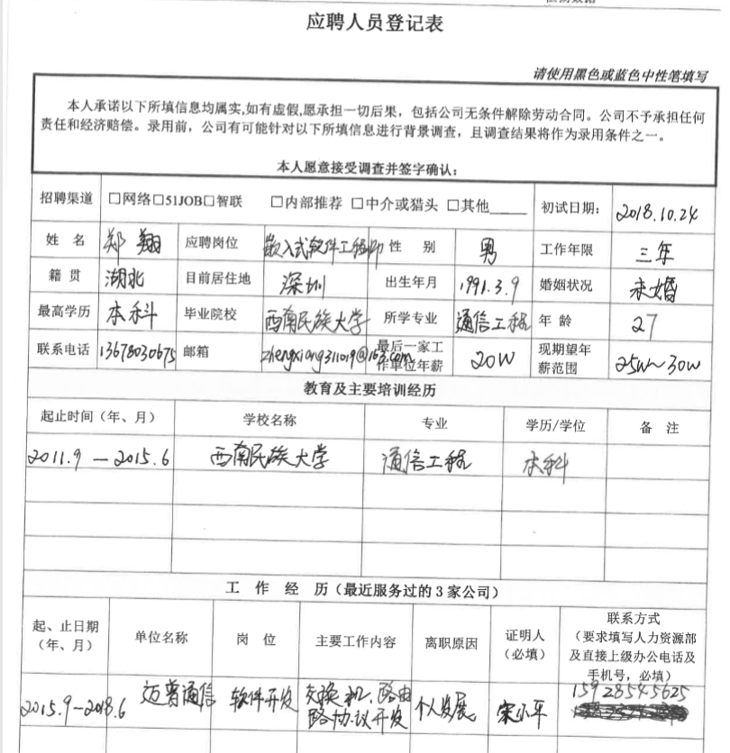

C语言基础良好，有一定的编码量，有相关网络知识  
对自己负责的工作内容比较熟悉，但负责的工作面较窄（交换机生成树协议，路由器ipsec协议，RPC报文解析及关联接口调用），不够深入  
思维能力不错，有解决问题的能力

